**Computer Graphics (Spring, 2015) Midterm Exam**

|  |  |
| --- | --- |
| Name: |  |

1. [20 points] Describe what “raster graphics” are.

In raster graphics, the image is produced as an array (*raster*) of picture elements (*pixels*) in frame buffer.

1. [20 points] Frame buffer is an array of pixels. Explain two properties specifying frame buffers
   * 1. Resolution: number of pixels – ( width x height )
     2. Depth (or precision) - bits per color component

1. [20 points] Most graphics architecture uses pipelining and its pipeline is similar as:



1. Describe what “Rasterizer” block does. (10 points)

Generate fragments from clipped primitives

* + 1. A fragment is a pixel carrying color, location, depth, etc.

E.g. generate pixels inside triangle for filled triangle

1. Explain what “Fragment processor” block does. (10 points)
   1. Update the pixels in the frame buffer from fragments
   2. Several things should be considered in this stage
      1. Visibility of fragment is checked from depth information
      2. Color of a fragment may be altered by texture mapping or bump mapping
      3. Effects (e.g. translucent, blending) are considered
2. [20 points] Describe what ‘homogeneous coordinate’ is and write a point $P={\left[α_{1},α_{2},α_{3}\right]}^{T}$ and vector $W={\left[β_{1},β_{2},β_{3}\right]}^{T}$ in homogeneous coordinate representation.

Homogeneous coordinate uses *4-dimensional* representation for *both points and vectors* in three-dimensional space

* + Homogeneous coordinate representation of point P
 $$p={\left[\begin{matrix}α_{1} & α_{2} & α_{3} & 1\end{matrix}\right]}^{T}$$

 + Homogeneous coordinate representation of vector $w$

$$w={\left[\begin{matrix}β_{1} & β_{2} & β_{3} & 0\end{matrix}\right]}^{T}$$

1. [20 points] Matrix form is better form implementation of affine transformations. Explain why?
   * + Matrix form is better for implementation because all affine transformations *can be expressed using same way*
     + It can accelerated by hardware
     + All cascade matrix multiplications can be combined into one matrix
2. [20 points] Describe which transformation can be executed by the following matrix?
   1. P’ = $\left[\begin{matrix}\cos{θ} & -\sin{θ} & 0 & 0 \\ \sin{θ} & \cos{θ} & 0 & 0 \\ 0 & 0 & 1 & 0 \\ 0 & 0 & 0 & 1\end{matrix}\right]$ p (10 points)

Rotation (3D) about z-axis

* 1. P’ = p (10 points)

Scaling : expand or contract along each axis

1. [20 points] Assume the following triangle △ABC. Describe the surface normal vector by inner product or cross product.

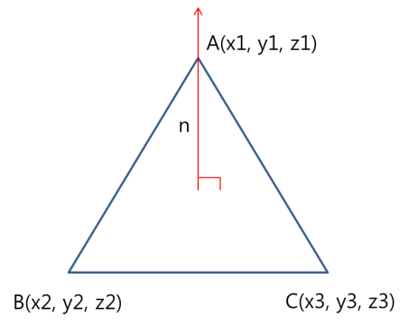

$\vec{a}=\left( x2-x1, y2-y1, z2-z1\right)$

$$\vec{ b}=\left( x3-x1, y3-y1, z3-z1\right)$$

$\vec{n}=\vec{a}×\vec{b}$

or

$$\vec{a}=\left( x1-x2, y1-y2, z1-z2\right)$$

$$\vec{ b}=\left( x3-x2, y3-y2, z3-z2\right)$$

$\vec{n}=\vec{b}×\vec{a}$

1. [20 points] Let’s assume that COP is located at the origin and the projection plane is z=d. Answer the following questions.
2. Give direct equation to calculate projected homogeneous coordinate (xp, yp, zp, 1) by using homogeneous coordinate (x, y, z, 1). (10 points)

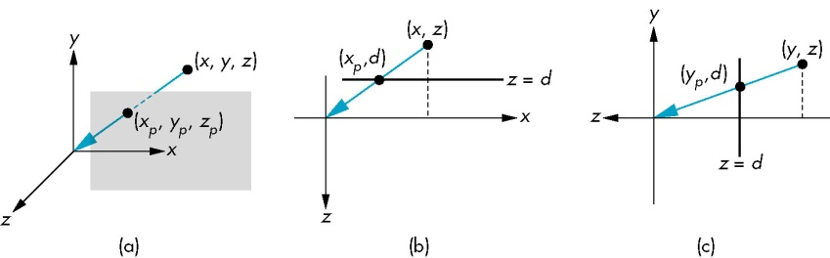

$$x_{p}=\frac{x}{z/d} ,y_{p}=\frac{y}{z/d} ,z_{p}=d$$

1. Give transformation matrix to transform (x, y, z, 1) to (xp, yp, zp, 1) (10 points)

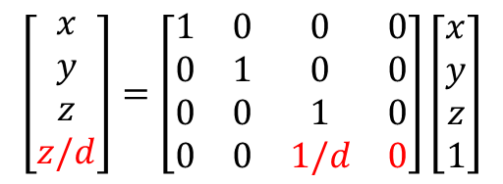 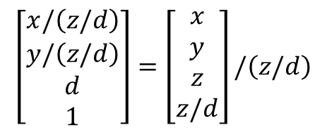

1. [20 points] Describe the normal vector n in the following cases.
2. Normal vector of the plane which is expressed by A $x+By+Cz+D=0$ (10 points)

n = [A B C]

1. Normal vector of unit sphere? ( Unit sphere equation: $f\left(p\right)=x^{2}+y^{2}+z^{2}-1=0$) (10 points)
$$n=\left[\begin{matrix}2x & 2y & 2z\end{matrix} \right]=2p$$

2. [20 points] Phong light model can be written as the following equation where l, n, r and v are four vectors indicating light, normal, reflection and viewer.
$$I=\frac{1}{a+bd+c^{2}}\left(k_{d}L_{d}\max\left(l∙n,0\right)+k_{s}L_{s}\max\left({\left(r∙v\right)}^{α},0\right)\right)+k_{a}L_{a}$$

3. How to compute reflection vector r ? (Assume that r is the perfect reflection vector. ) ( 10 points)

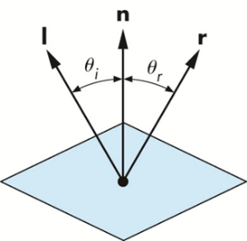

$l+r=2\left|l\right|\cos{θ}n$

$l+r=2\left(l∙n\right)n$

$$∴r=2\left(l∙n\right)n-l$$

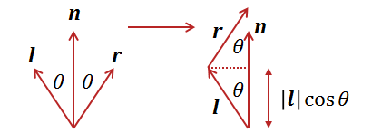

1. Blinn introduced halfway vector h to reduce the complexity. Explain what he did and why it can reduce the complexity (10 points)

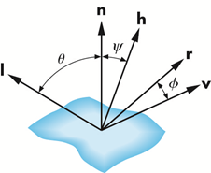

* + Halfway vector ***h***: normalized vector of $l+v$
 $h=\left(l+v\right)/\left|l+v\right|$

 + Replacing $r∙v$ with $n∙h$
    - *Computation of $r$ can be avoided*
    - $I_{s}=max⁡\left(k_{s}{\left(r∙v\right)}^{α}L_{s},0\right)$ (Phong)
    - $I_{s}=max⁡\left(k_{s}{\left(n∙h\right)}^{β}L_{s},0\right)$ (Blinn-Phong)